Vlad Predovic

CS 340

Due 10/16/2015

Assignment 2

[My website! --> http://web.engr.oregonstate.edu/~predoviv/CS340/hw2.php](http://web.engr.oregonstate.edu/~predoviv/CS340/hw2.php)

**Disclaimer:** For my E-R diagrams, please ignore the little arrows. I was having trouble creating lines without arrows connecting the different diagrams. The big awkward arrows were put in afterwards to satisfy participation constraints.

a. Exercise 2.1 Explain the following terms briefly:

**Attribute:** A property or description of an entity.

**Domain:** Set of possible values for an attribute.

**Entity:** An object used in the DB/DBMS that exists in the real world.

**Relationship:** Association between 2+ entities.

**Entity set:** Grouped entities with similar features.

**Relationship set:** An association between entity sets. (This 🡪 ‘does’ 🡪That)

**One-to-many relationship:** Constraint where 1 entity A can be associated to many of entity B.

**Many-to-many relationship:** Many of entity A can be associated to many of entity B.

**Participation constraint:** Whether or not relationships have to involve certain entities. Can be total, or partial.

**Overlap constraint:** Whether two subclasses can contain the same entity.

(Ex: Can employee be contracted and hourly?)

**Covering constraint:** All entities in subclasses are covered by those in a ‘master’ entity.

**Weak entity set:** Entity that cannot be defined without some key attributes from another entity

(Ex: dependents of someone on a form)

**Aggregation:** Used to indicate that a relationship set participates in another relationship set.

**Role indicator:** Describe purpose of entity in a relationship, if the entity takes on more than one role. (Example: Employee - Manages – Employee)

b. Exercise 2.3: 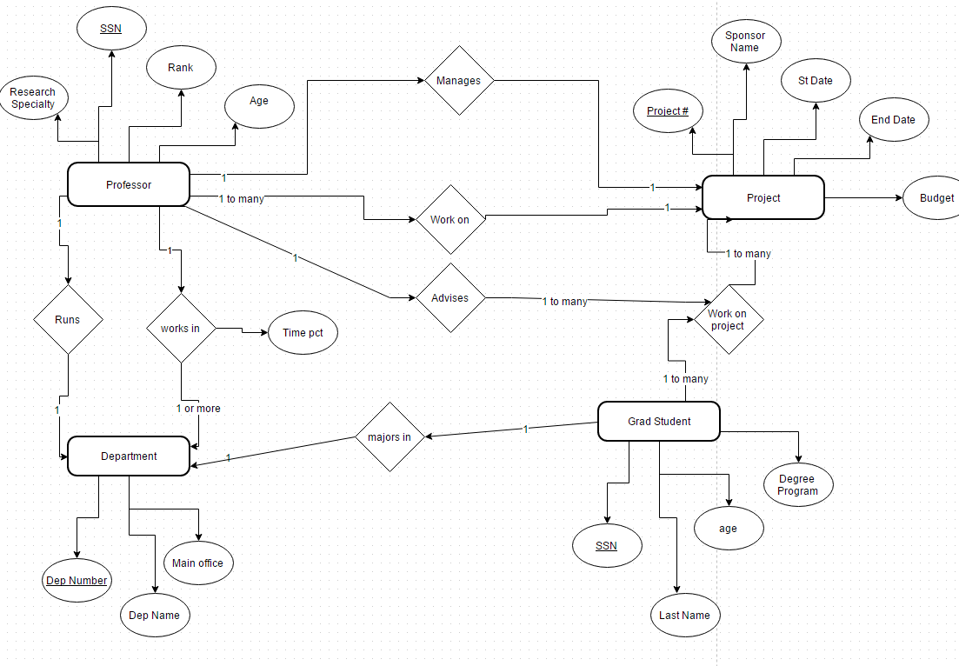

Oversees

c. Exercise 2.6:

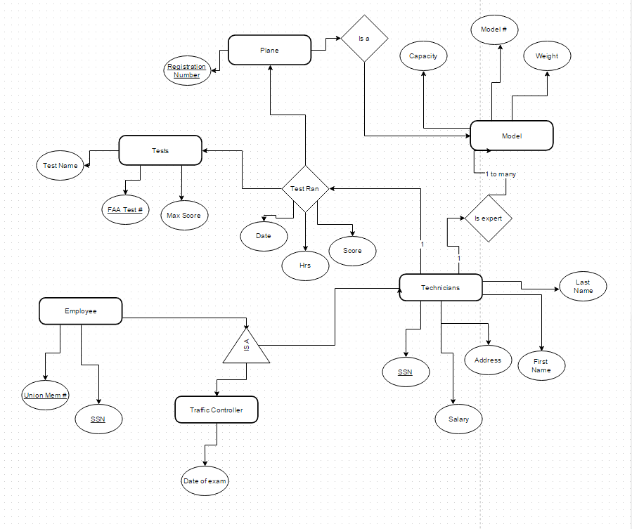

1. Covering constraint on the Traffic Controllers and Technicians since these are subclasses of Employee.
2. We would need to somehow relate the “Is a” relation with the “is expert” relation to assure that each technician was an expert on the plane they were conducting tests on. I am not sure this is possible.

d. Exercise 2.8:

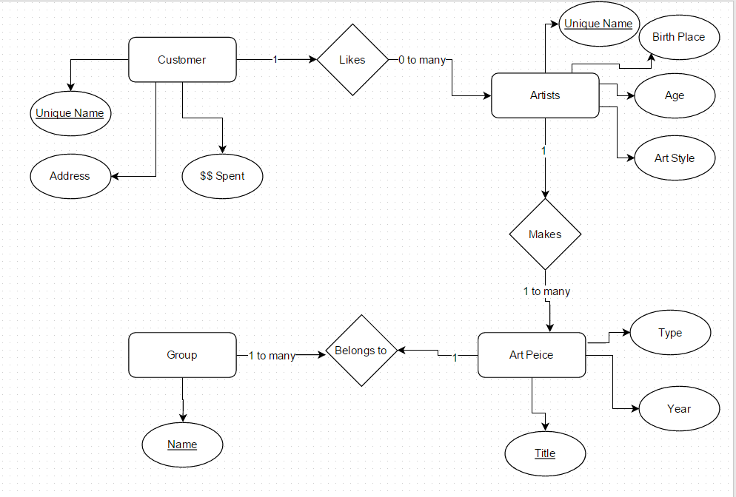

Likes

e.

Database serving a Spanish to English services company

* Employees: EID, Name, PW, phone number, admin(binary)
* Clients: CID, Client Name, password, Email, phone number, address
* Work: WID, Date requested, Client Name, Date Started, Completion Date, Hrs. Worked
* Job: Job type, Date started, DID
* Service: Service type, Location
* Documentation(files): DID, Description, Media Type, CID, Date received

Introduction:

The database project will support a company that provides services for bridging the gap between English and Spanish speakers. This could be something as simple as translating a document or personal like communicating between a sick patient and their doctor and even developing learning material for non-English speakers. The company provides both jobs and services to its clients, and needs a way to keep track of this. Additionally, long-term clients will have accounts so they can automatically request additional items. The company needs a way to keep track of the many documents being worked on, be able to add and remove users, and keep track of hours worked on a job for all the employees.

Detailed Application Requirements:

The first implementation is a way for employees to see the work being done in table form. This will require some form of login/session-protected page with a table drawing joined values from the database. The table will portray jobs by creation date and have details like who is the ‘lead’ working the job, links to a file attached if applicable, and the status of the job/service to be completed. Additionally the owners of the company want to be able to adjust values themselves such as the time worked on the job, changing current parameters, and adding additional jobs. These user-oriented applications can be done through the implementation of form queries in php.

Another requirement that was decided upon with my sponsors was a way for clients to view the jobs they have requested, those they have completed, and be able to request more work. The issue here is that the company does not want to receive emails from regular clients each time a new job or service is needed. Regulars should have a way to submit work they want done and view their current history. Accounts for each long-term client will be added requiring that they be added to the database as a ‘client’ object. Once logged on a load query and some php code will bring up a table showing the client their history with a form option to add another request.

The company wants to be able to upload and keep track of information. This company will be dealing with documents a lot of the time due to the translating services that are provided. These need to be archived and connected to the rest of the database. The user will have a way to upload a file in relation to each job. Once this is complete, the document will automatically be related to a client, a work date, and a ‘lead’ employee through the implementation of the relational database. However, one of the limitations is the storage capacity of the servers. A work-around in consideration is using an existing system such as the Google Drive or Microsoft’s One Drive to upload files and then providing the URL link to these to be saved into the database. To users a file link would be displayed for the current job that would lead them to where the file that is being worked on is located.

This section illustrates your conceptual design in the form of an ER diagram. Also provide discussion of other considerations such as performance and storage requirements.

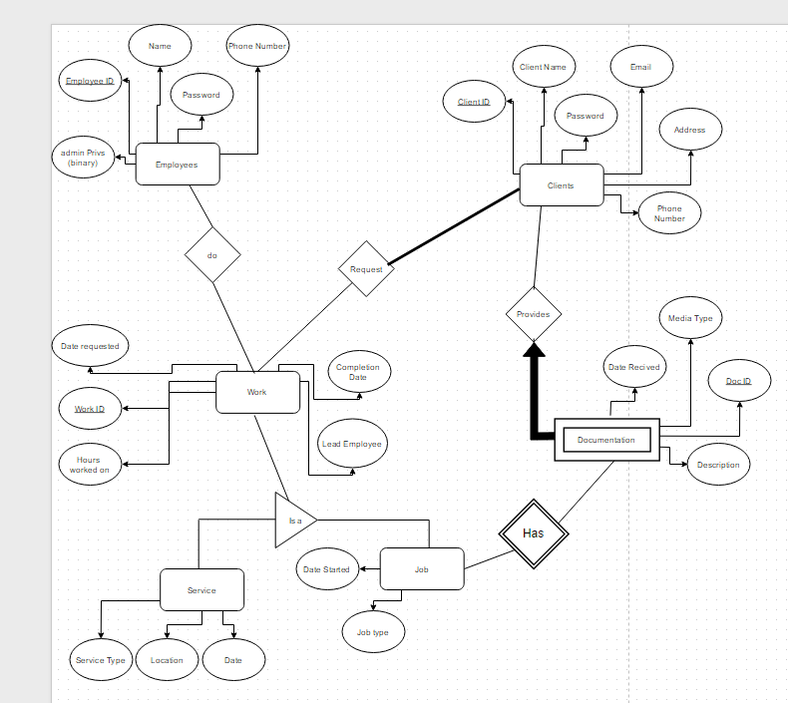

Describe the functionalities of your system in the form of screenshots of your user interfaces. Describe the purpose of each widget. It might be easier to do this by providing typical workflows of the intended users or user groups. For example, if your application involves a university registration, perhaps you can show what forms are needed for a student to register for a class and those for an advisor to track the enrollment of the courses. Again, describe various considerations for your design (user groups, security needs, administration concerns, storage, performance, etc.).

Table to Show Jobs in Work:

|  |  |  |  |  |  |
| --- | --- | --- | --- | --- | --- |
| Work ID | Date Started | Lead | Client | File | Work Status |
| 3235 | 5/4/2212 | Vlad Pred | BBB LC | www.zzz.com | Incomplete |
|  |  |  |  |  |  |

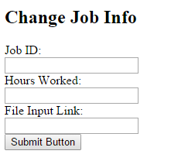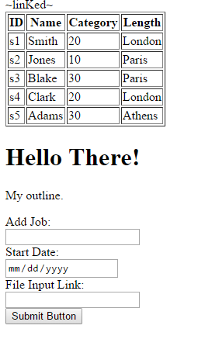

These are the couple of the forms Administrators and clients will be able to use to enter their information. On the left you can add a job along with a start date and a file link. This can be used by clients to enter jobs on their page. On the right an employee can enter values to alter their job info. The client has also requested the ability to query all requests/jobs by a certain employer and that these appear on a separate printable page.

Below is a rough sketch of what the Administration page might look like for an employee:

